**TASK**

1. **TAKE BACKUP OF AMI ON DAILY BASIS IN INTERVAL OF 12HR USING ANY LANGUAGE.**

**I am using Linux scripting for this task**

**Problem statement 🡪 need to take backup of instance in form AMI on daily basis in 12hr of interval**

**APPROCH**

* First, we need to configure aws with that or different instance (need to keep in mind that user should have full access of ec2 so that he can create Ami at least)
* We need to write a script that will take backup of instance (for this we will need ***instance id***  and some knowledge about aws cli command of ec2 ) **I am referring this link** [**https://docs.aws.amazon.com/cli/latest/reference/ec2/create-image.html**](https://docs.aws.amazon.com/cli/latest/reference/ec2/create-image.html)
* After this we just need to add a crontab job for this .sh file to execute at every 12hr

STEPS

STEP 1 Get Access key and secret key of user who has sufficient authority to create Ami and manage them

STEP 2 Launch the instance. I am using ubuntu for this and I am taking backup of this instance only.

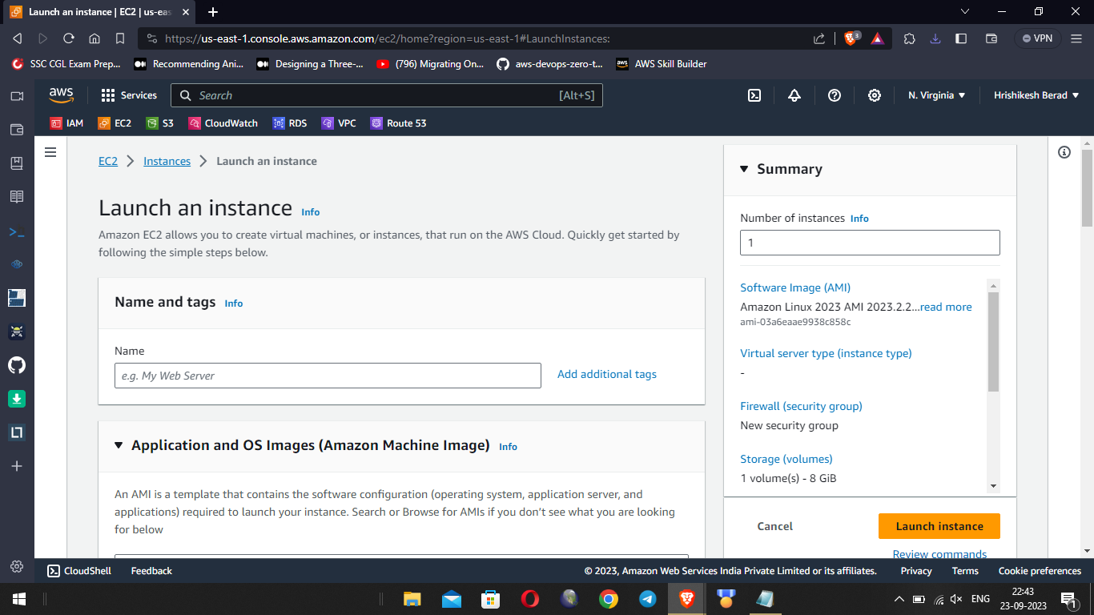

**STEP 3** Get ssh access of instance using public Ip of instance [note: make sure you have private key available in folder where you are taking ssh of instance]

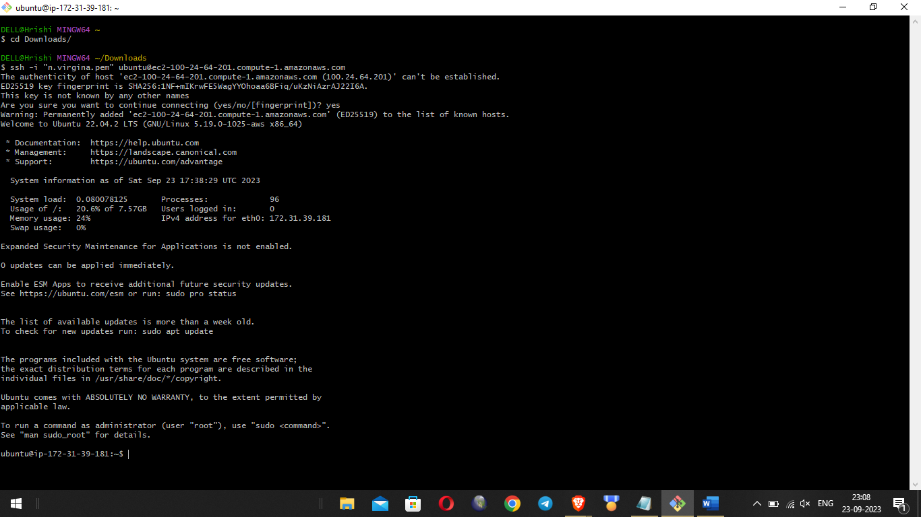

STEP 4 install aws cli in it using command sudo apt-get update && sudo apt-get install awscli

STEP 5 After this we need to configure aws in our instance to do this run command “**aws configure” , enter your access key and secret key**

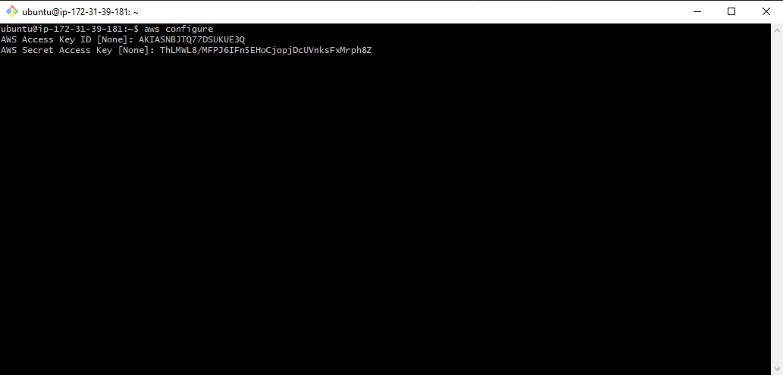

**STEP 6** Create a shell script backup-ami.sh that will create the AMI backup**.**

And type this in script file

#! /bin/bash

INSTANCE_ID="i-08f06ea37fe302f86” # Replace with your actual instance ID

AMI_NAME="DailyBackup-$(date +\%Y\%m\%d\%H\%M)"

DESCRIPTION="Daily Backup - $(date +\%Y\%m\%d\%H\%M)"

# Create the AMI

**aws ec2 create-image --instance-id "i-08f06ea37fe302f86" --name "$AMI_NAME" --description "$DESCRIPTION" --no-reboot**

# Print a message to verify

echo "Created AMI: $AMI_NAME"

***use this link to add more details in this file*** [**https://docs.aws.amazon.com/cli/latest/reference/ec2/create-image.html**](https://docs.aws.amazon.com/cli/latest/reference/ec2/create-image.html)

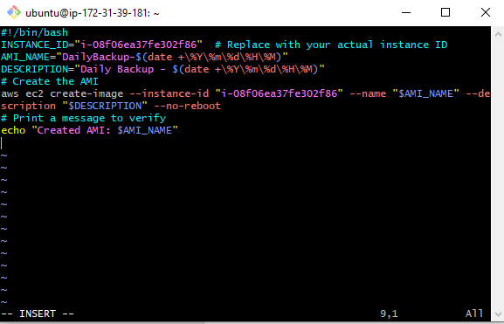

**STEP7** Make the script executable using using ***chmod +x backup-ami.sh*** command

**STEP 8** Now we have to schedule this task to run at interval of 12hr every day. For that we have to create a crontab job. Open crontab editor using crontab -e

And add this 0 */12 * * * /home/ubuntu/backup-ami.sh

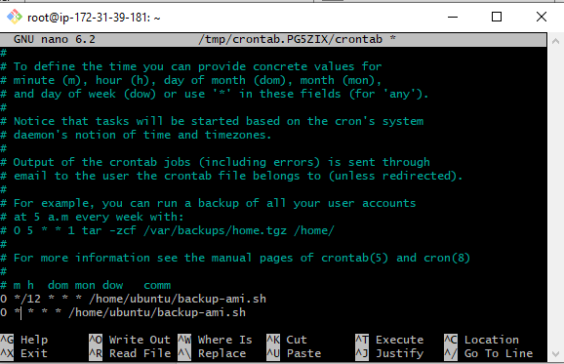

**NOTE: Just to check I have added every hour crontab job**

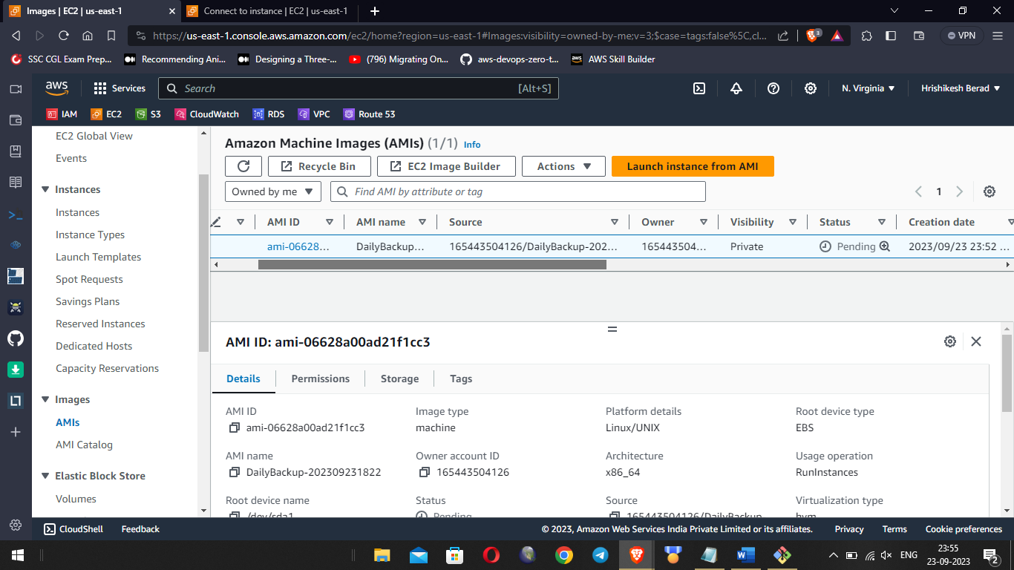

**AMI is successfully created**